**Ideation Phase**

**Define the Problem Statements**

|  |  |
| --- | --- |
| Date | 30 June 2025 |
| Team ID | LTVIP2025TMID35759 |
| Project Name | Transfer Learning-Based Classification of Poultry Diseases for Enhanced Health Management |
| Maximum Marks | 2 Marks |

**Customer Problem Statement:**

Create a problem statement to understand your customer's point of view. The Customer Problem Statement template helps you focus on what matters to create experiences people will love.

The Customer Problem Statement template helps identify challenges from the user’s perspective to build impactful and relevant solutions. For poultry disease classification, understanding farmers’ pain points is critical to designing a tool that is practical, scalable, and beneficial across regions.

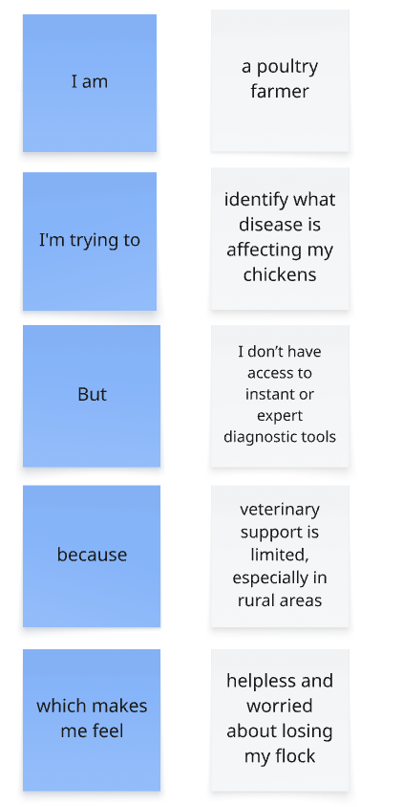

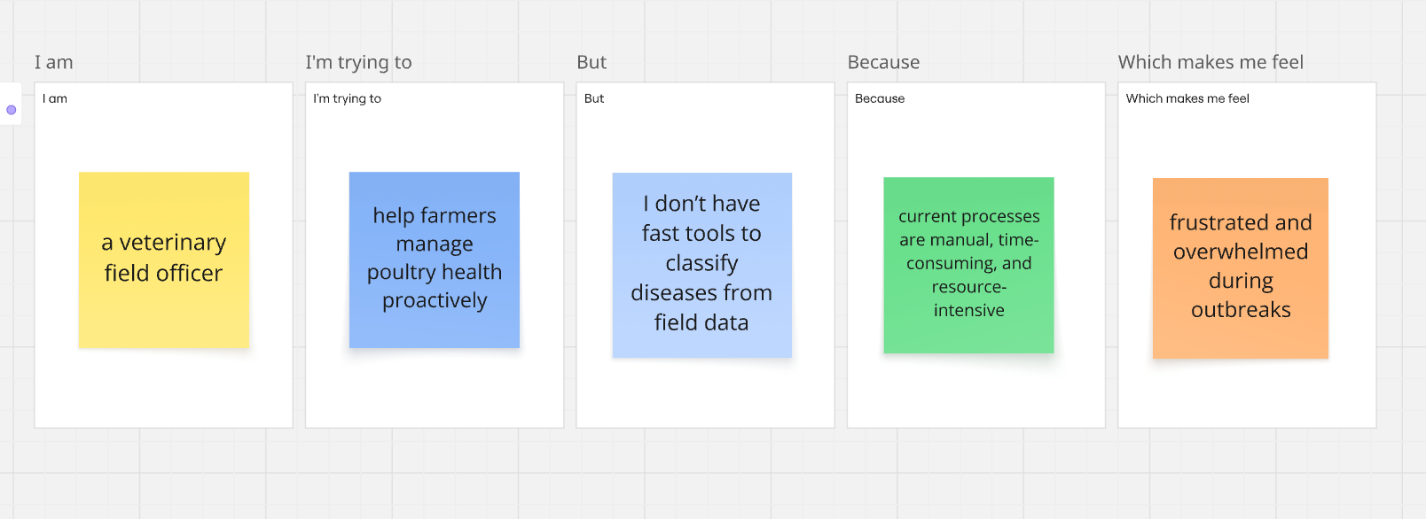**Example:**

|  |  |  |  |  |  |
| --- | --- | --- | --- | --- | --- |
| **Problem Statement (PS)** | **I am (Customer)** | **I’m trying to** | **But** | **Because** | **Which makes me feel** |
| PS-1 | a poultry farmer | identify what disease is affecting my chickens | I don’t have access to instant or expert diagnostic tools | veterinary support is limited, especially in rural areas | helpless and worried about losing my flock |
| PS-2 | a veterinary field officer | help farmers manage poultry health proactively | I don’t have fast tools to classify diseases from field data | current processes are manual, time-consuming, and resource-intensive | frustrated and overwhelmed during outbreaks |